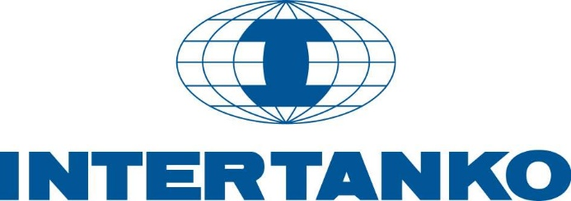

**Policy on GHG Emissions Reductions from International Shipping**

*(revised Nov 2021)*

1. INTERTANKO, working with other stakeholders, strongly supports IMO to develop and adopt additional measures to ensure a successful implementation of the climate targets set in the Initial IMO Strategy for GHG Emissions Reductions from International Shipping.
2. INTERTANKO supports the development of policy actions that:
   1. are developed and implemented through an international regime;
   2. achieve the IMO set levels of ambitions for 2030 and 2050;
   3. result in achieving the goal of net zero CO2 emissions by 2050 for international shipping;
   4. actively pursue and encourage the participation of all stakeholders in the development and availability of the technologies and fuels needed for international shipping to meet this goal safely;
   5. facilitate the proper training of ships’ crews in the use and handling of the new technologies and fuels developed to meet this goal; and
   6. provide transparency to maintain the current level playing field and do not place a disproportionate financial and operational burden on the industry.
3. Based on the principles iterated above and working with other stakeholders, INTERTANKO will seek appropriate mechanisms which contribute to accelerated R&D activity for the development and deployment of solutions to make the 2050 level of ambition achievable, and which will lead to a total de-carbonisation of transportation at sea.
4. INTERTANKO will engage with other relevant stakeholders, such as financial and chartering institutions, to review and assess any independent GHG related initiatives to ensure they are consistent with INTERTANKO’s GHG policy as well as IMO’s climate objectives, and avoid safety, commercial and unnecessary reporting implications
5. INTERTANKO supports IMO in its drive for international measures. Should local, national and/or regional measures be unavoidable, INTERTANKO will work with governments and other stakeholders to ensure that such measures:
   1. are harmonised with the IMO GHG Strategy and
   2. avoid provisions which could disrupt or fragment trade and lead to unintended safety and commercial implications.
6. INTERTANKO Members recognise that, when available, an accelerated phase-in of new technologies and alternative fuels must be supported through a market-based mechanism (MBM). Therefore, INTERTANKO supports a Fuel Levy that is simple, reasonably economical, and a transparent MBM scheme. It is essential that funds collected from ships are directed to efforts to decarbonize shipping.