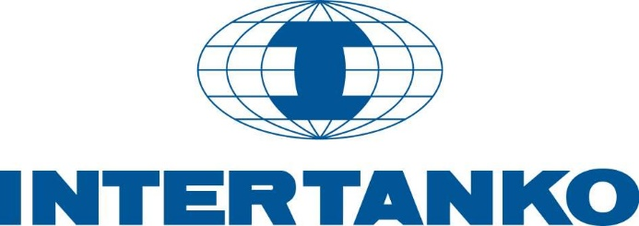

# **PPS Frequently asked questions (FAQs)**

# What is the Payment Performance System (PPS)?

INTERTANKO is committed to improving the sustainability of the tanker industry. This important focus area forms part of the Association's five-year plan and is made up of a number of inter-related initiatives which collectively provide Members with real, tangible, practical benefits. These initiatives include the use of a freight and demurrage payment monitoring tool, the Payments Performance System (PPS).

PPS provides a robust way of monitoring, measuring and benchmarking the freight and demurrage payment performance of the charterers of INTERTANKO Member vessels, by collecting fixture and payment data in order to calculate and present a number of key performance metrics which will allow INTERTANKO to engage in well-informed dialogue with charterers and ultimately to reduce these unacceptable payment delays.

# Is my data safe?

The Payment Performance System uses a number of assets and techniques to keep your data safe and secure:

* **Data Storage:**

Data is stored and served from a state-of-the-art data centre which complies with SAS 70, SSAE 16 and Safe Harbor protocols and security standards.

* **Data encryption in transit:**

All data traffic into and out of the system is encrypted using HTTP Secure, a web standard protocol for securing data transmission over the internet, as commonly used in e-commerce, online banking and other applications where protection against eavesdropping is required.

* **Data encryption at rest:**

All sensitive data is stored using strong encryption (Advanced Encryption Standard) in the database. In the highly unlikely even of unauthorised access to the database, the exposed data is meaningless.

* **Internal segregation of users and transaction data:**

Each Member’s data is encrypted using a key unique to that Member. In addition to the logical separation of Members within the system, this ensures that it is not possible for one Member’s data to be accessed by another.

The above factors combine to make PPS a strictly confidential, highly secure and anonymous database/benchmarking tool exclusive for the exclusive use of contributing Full INTERTANKO Members

# What does the PPS do for me?

PPS allows you to compare how one charterer’s payment performance compares with that of other charterers, and how your experience relates to that of other Members. It will allow INTERTANKO to have at hand, hard evidence to show any poor-performing charterer when discussing payment performance, without compromising the privacy of any one individual Member.

# Who is eligible to access and use the system?

Only Full Members of the Association that are contributing with their data and certain members of Staff from the Secretariat may access and use the system.

Access to PPS is not permitted to Associate Members (Charterers, Brokers, P&I Clubs, Marine Suppliers, Educational Institutes etc.) and non-Members.

# What will using the PPS cost me?

PPS is free of charge for INTERTANKO Members. The only cost to you is for your time to put your freight and demurrage payments into the system, or to send your data to us for us to put in.

# How quickly will I see my data registering in the system?

As soon as you upload your data, it will register in the PPS and be visible on the graphs.

# What is the ultimate goal?

Changing poor payment behaviours and raising awareness of payment delinquency within the industry are the ultimate aims.